Kapture - AssetsTool (Assets Management Tool) Unit Test Cases

Contents
1. User System Access 2
2. Channel and Locale Selection 3
3. Upload Assets 5
4. Already Exists - Overwrite / Discard 11
5. Reset 15

Kapture - AssetsTool (Assets Management Tool)
Unit Test Cases
Application URL: https://na.dev.mgss.oc.mazda.com/assetstool
Application: assetstool.war (/assetstool) | Version: v2 | Date: 16-Oct-2026
- Unit Test Case Summary:
# | Test Cases Processes | No. of Test Cases | No. of Success | No. of Failure | Status
1 | User System Access | 1 | 1 | 0 | Pass
2 | Channel and Locale Selection | 3 | 3 | 0 | Pass
3 | Upload Assets | 5 | 5 | 0 | Pass
4 | Already Exists - Overwrite / Discard | 4 | 4 | 0 | Pass
5 | Reset | 1 | 1 | 0 | Pass
 | Total | 14 | 14 | 0 | Pass

User System Access
- User should be able to open the Assets Management Tool using the application URL.
Steps:
1. Log in to MGSS with a valid user.
2. Open the URL: https://na.dev.mgss.oc.mazda.com/assetstool
Expected Result: The Upload Assets screen is displayed with the Channel drop-down (Accessories, Group Message, Service Information, Service Manuals, Static Content, Videos), the Upload File(s) field and the Reset / Upload buttons.
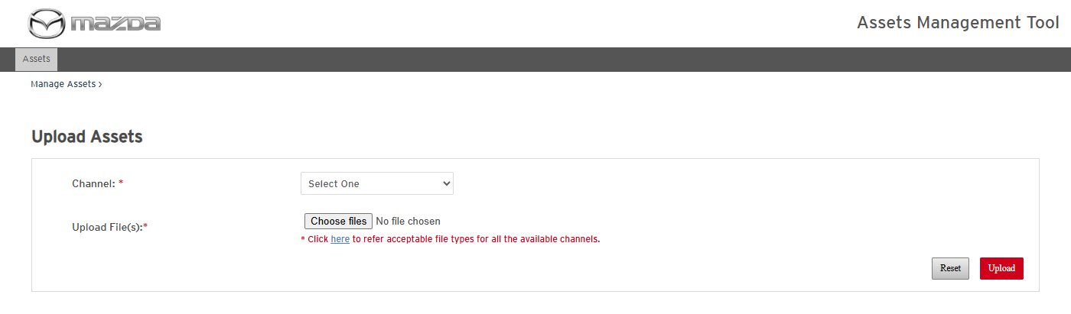
Upload Assets screen
Status: Pass
Remarks:

Channel and Locale Selection
The same process applies to the other allowed channels, each with its own acceptable file types: Accessories (.pdf), Group Message (.jpg, .png - no Locale level, files go to GROUP_MESSAGE\images), Service Manuals (.jpg, .gif, .tif, .bmp, .png) and Videos (.pdf, .wmv, .mpeg, .wma, .wav, .flv, .swf, .mp4). The full list is in the acceptable file types popup (AT.0004).
- User should be able to select the Service Information channel and view its locales.
Steps:
1. Select Service Information in the Channel drop-down.
2. Expand the Locale drop-down.
Expected Result:
- The Locale drop-down (mandatory *) lists exactly the locale folders of SERVICE_INFORMATION on the server (e.g. en_US, es_MX).
- Acceptable File Types shows .pdf, .doc, .docx, .xls, .xlsx, .zip, .jpg, .gif, .tif, .bmp, .png.
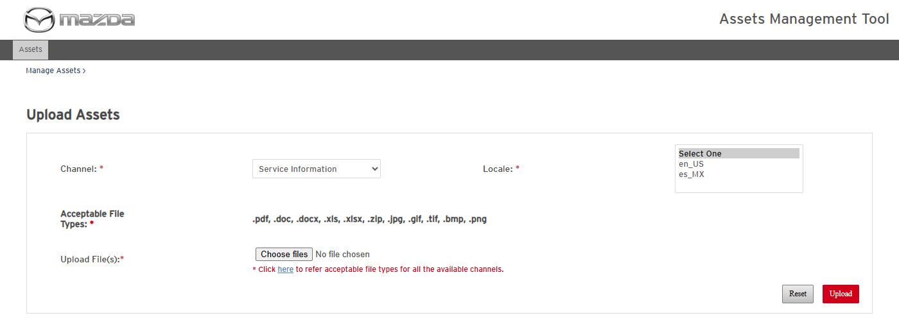
Service Information - locales and acceptable file types
Status: Pass
Remarks:

- User should be able to select the Static Content channel and view its locales.
Steps:
1. Select Static Content in the Channel drop-down.
2. Expand the Locale drop-down.
Expected Result:
- The Locale drop-down lists the locale folders of STATIC_CONTENT on the server.
- Acceptable File Types shows the Static Content list (.gif, .tif, .jpg, .bmp, .png, .pdf, .doc, .docx, .xls, .xlsx, .wmv, .mpeg, .wma, .wav, .flv, .swf, .mp4, .zip, .css, .js, .up, .cab, .xml, .exe).
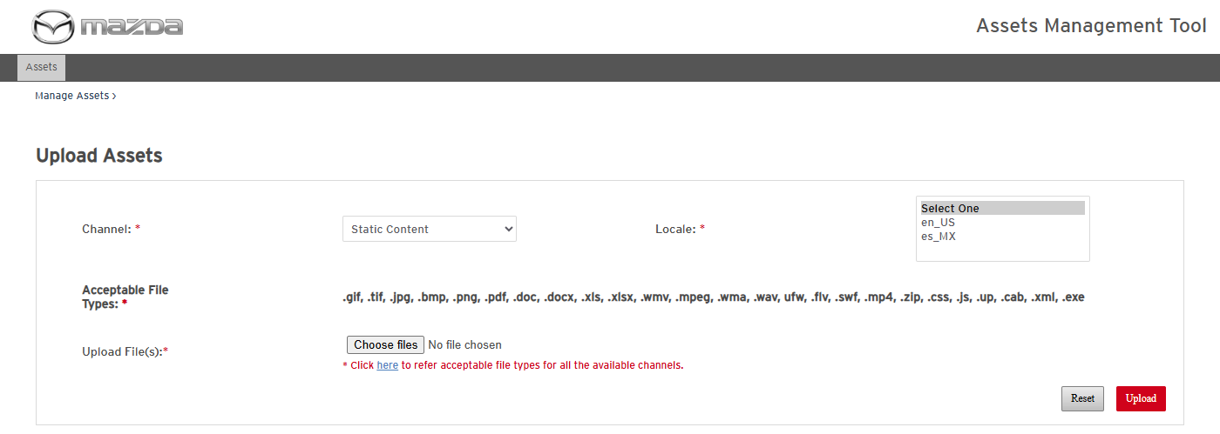
Static Content - locales and acceptable file types
Status: Pass
Remarks:

- User should be able to view the acceptable file types of all channels.
Steps:
1. Click the here link in "Click here to refer acceptable file types for all the available channels".
Expected Result: The Allowed File Types Matrix popup lists every channel with its acceptable file types.
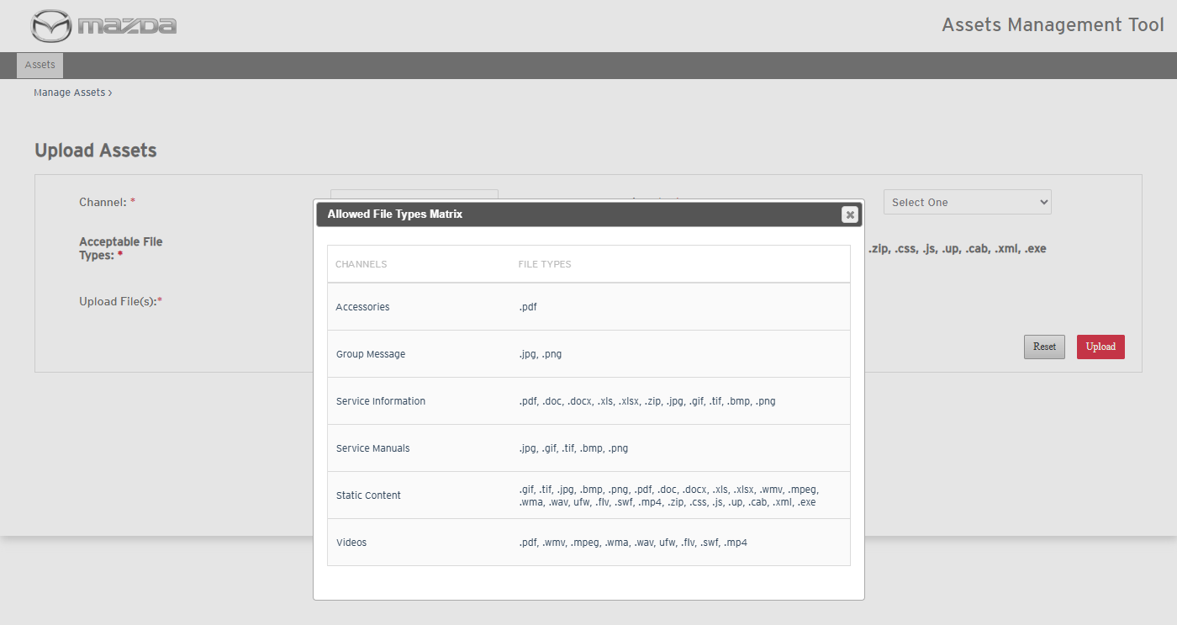
Allowed File Types Matrix
Status: Pass
Remarks:

Upload Assets
The same process applies to the other allowed channels, each with its own acceptable file types: Accessories (.pdf), Group Message (.jpg, .png - no Locale level, files go to GROUP_MESSAGE\images), Service Manuals (.jpg, .gif, .tif, .bmp, .png) and Videos (.pdf, .wmv, .mpeg, .wma, .wav, .flv, .swf, .mp4). The full list is in the acceptable file types popup (AT.0004).
- User should be able to upload a file to the Service Information channel.
Steps:
1. Select Channel Service Information and Locale en_US.
2. Choose one .pdf file in Upload File(s) and click Upload.
Expected Result:
- A processing popup is shown while the file is uploaded.
- The Results Summary shows the file with Status Success and the path ...\library\MAZDA\SERVICE_INFORMATION\en_US\pdf\<file name>.pdf.
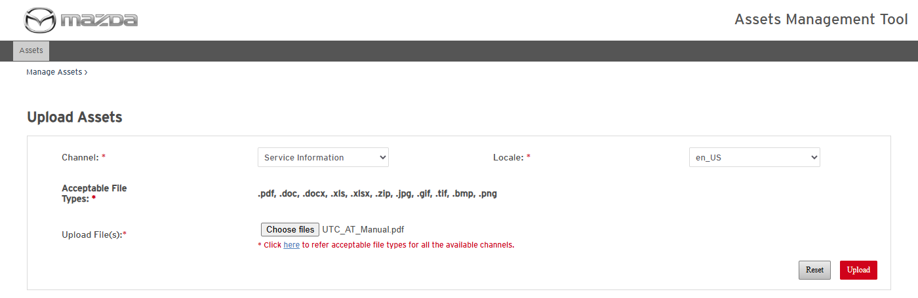
Channel, locale and file selected
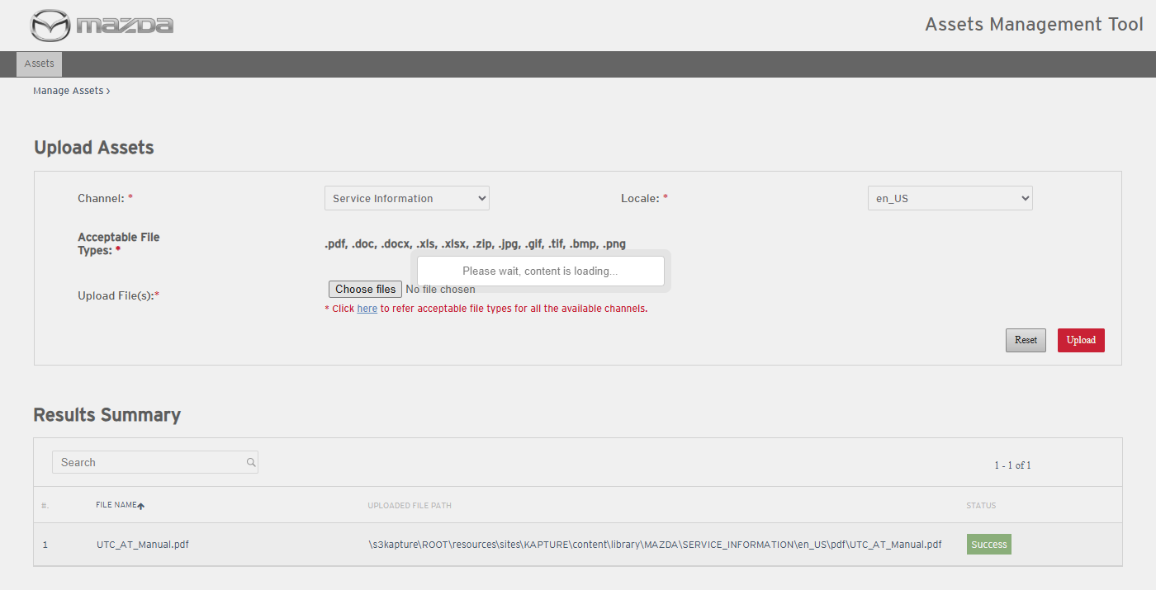
Processing popup
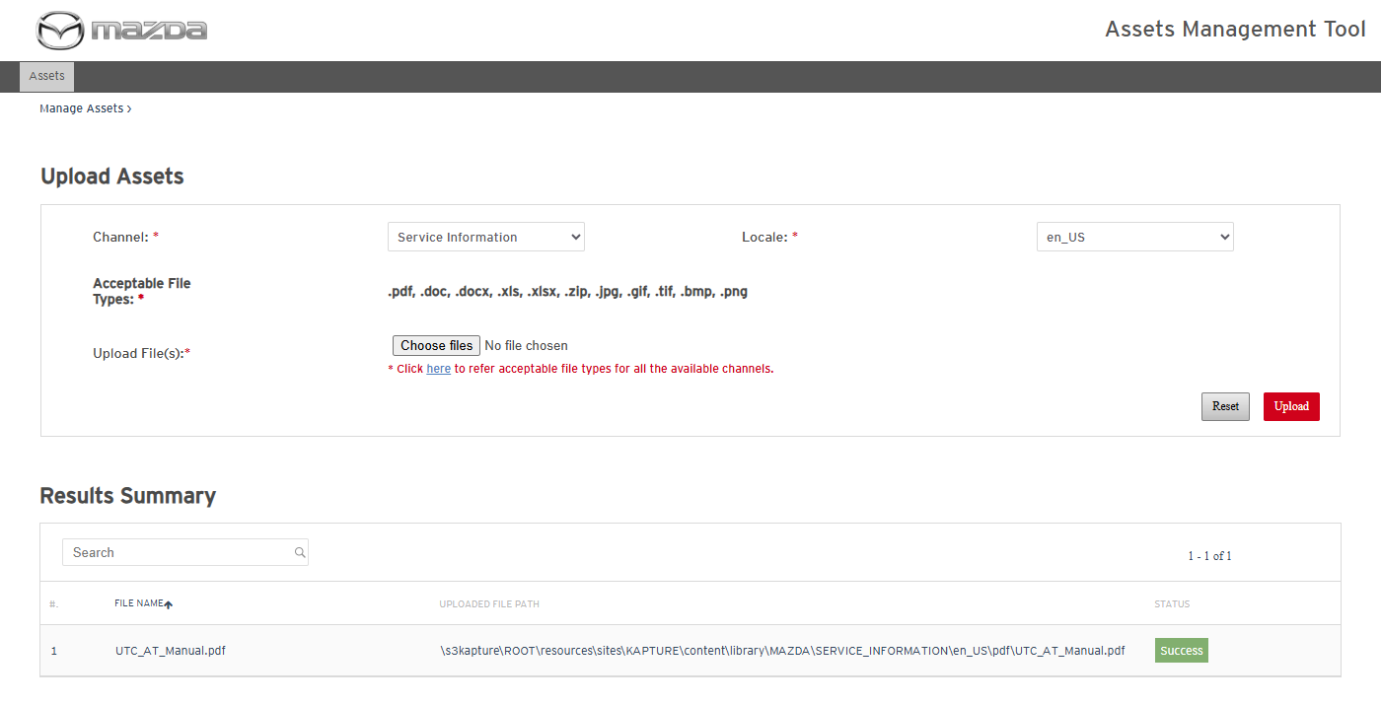
Upload result - Success
Status: Pass
Remarks:

- User should be able to upload several files to Service Information in one upload; each file type goes to its own folder.
Steps:
1. Select Channel Service Information and Locale en_US.
2. Choose a .docx, a .png and a .xml file together and click Upload.
Expected Result:
- The .docx goes to SERVICE_INFORMATION\en_US\docx and the .png to SERVICE_INFORMATION\en_US\image (Success).
- The .xml is not a Service Information type: Failed - "File is not acceptable for the selected channel."
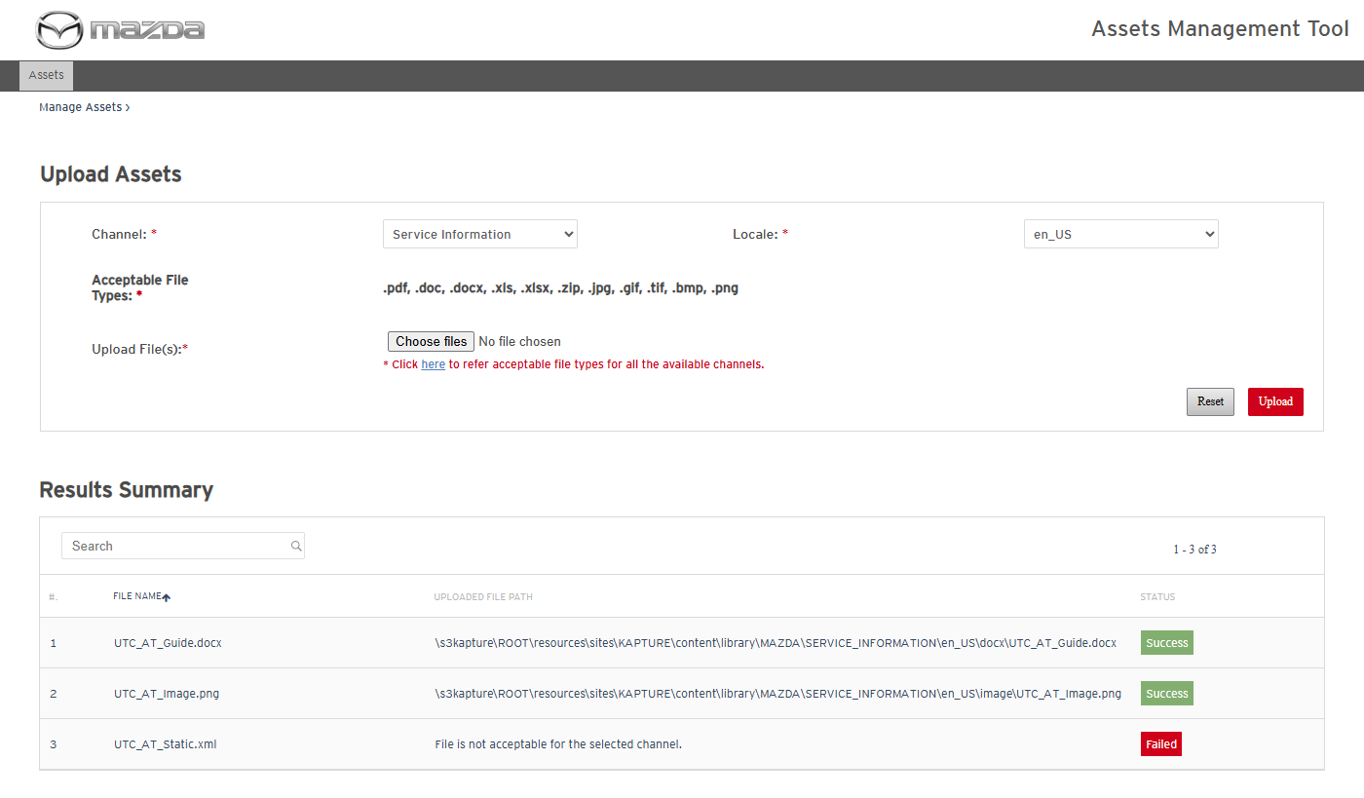
Multiple files - result per file
Status: Pass
Remarks:

- User should be able to upload files to the Static Content channel.
Steps:
1. Select Channel Static Content and Locale es_MX.
2. Choose a .xml, a .css and a .png file together and click Upload.
Expected Result: All files are uploaded with Status Success into STATIC_CONTENT\es_MX\xml, css and image.
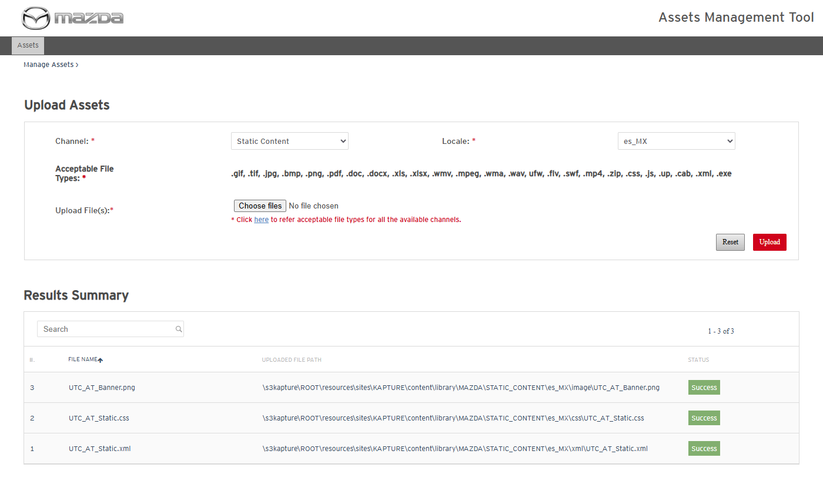
Static Content upload - Success
Status: Pass
Remarks:

- System should reject a file type that is not acceptable for the selected channel.
Steps:
1. Select Channel Service Information / Locale en_US, choose a .txt file and click Upload.
Expected Result: The file is listed with Status Failed and "File is not acceptable for the selected channel."; nothing is written on the server.
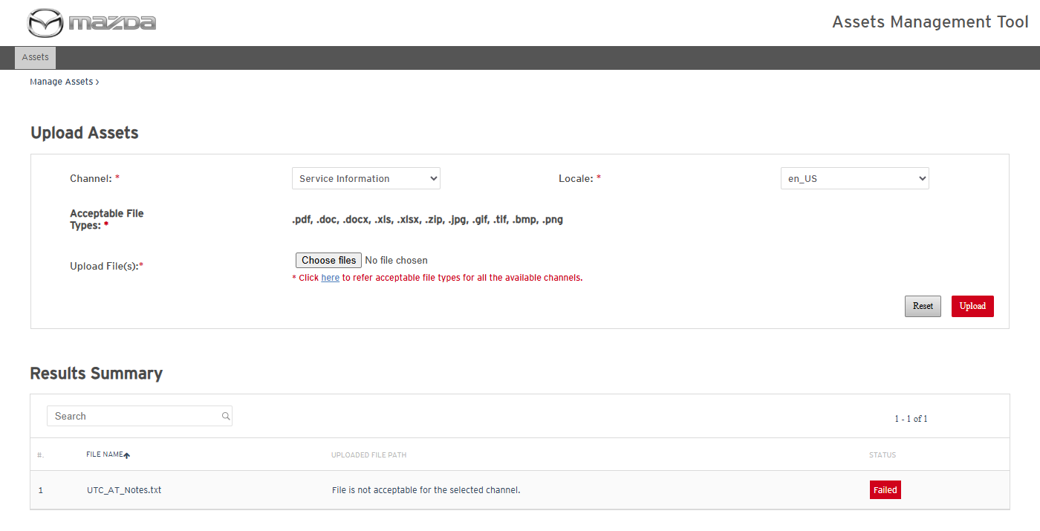
Not acceptable file type
Status: Pass
Remarks:

- System should not allow upload when mandatory fields are missing.
Steps:
1. Click Upload without a channel, locale or file.
2. Select Channel Static Content without a locale and click Upload.
Expected Result: "Please fill all the fields marked as mandatory (*)." is shown and nothing is uploaded.
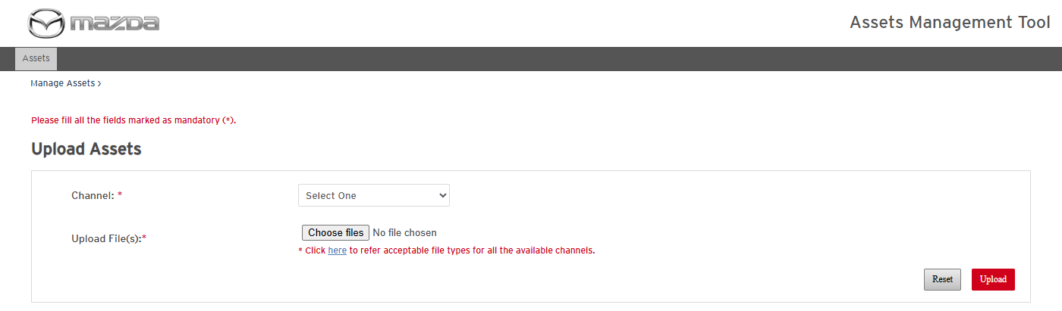
Nothing selected
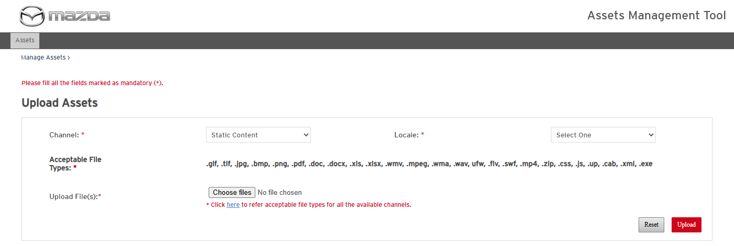
Channel without locale
Status: Pass
Remarks:

Already Exists - Overwrite / Discard
- System should flag a file that already exists at the target location instead of replacing it.
Pre-condition: AT.0005 executed (the .pdf already exists in SERVICE_INFORMATION\en_US\pdf).
Steps:
1. Select Service Information / en_US and upload a changed file with the same file name.
Expected Result:
- The file is listed with Status Already Exists and a selection check box.
- Overwrite and Discard buttons are shown; the file on the server is not changed yet.
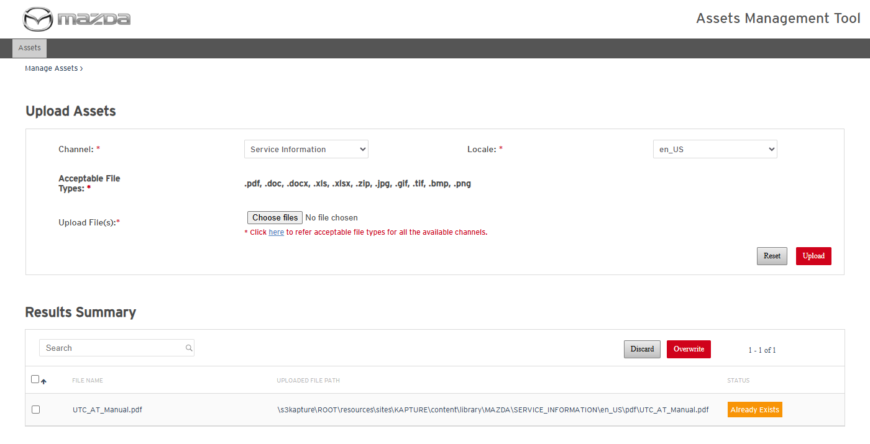
Already Exists with Overwrite / Discard
Status: Pass
Remarks:

- System should not allow Overwrite without a selected row.
Steps:
1. Click Overwrite without selecting a row.
Expected Result: "Please select atleast 1 row to overwrite." is shown and no file is changed.
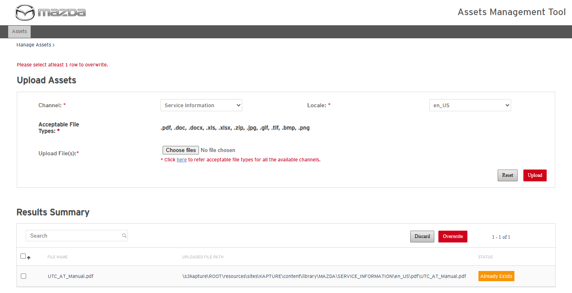
No row selected
Status: Pass
Remarks:

- User should be able to overwrite an existing file.
Steps:
1. Select the Already Exists row and click Overwrite.
Expected Result: The row Status becomes Success and the file on the server is replaced by the new one.
Overwrite result - Success
Status: Pass
Remarks:

- User should be able to discard the upload of an existing file.
Steps:
1. Upload the same file again, select the Already Exists row, click Discard and confirm with Yes.
Expected Result: "Are you sure, you wish to discard the selected files ?" is asked; the row is removed and the file on the server is unchanged.
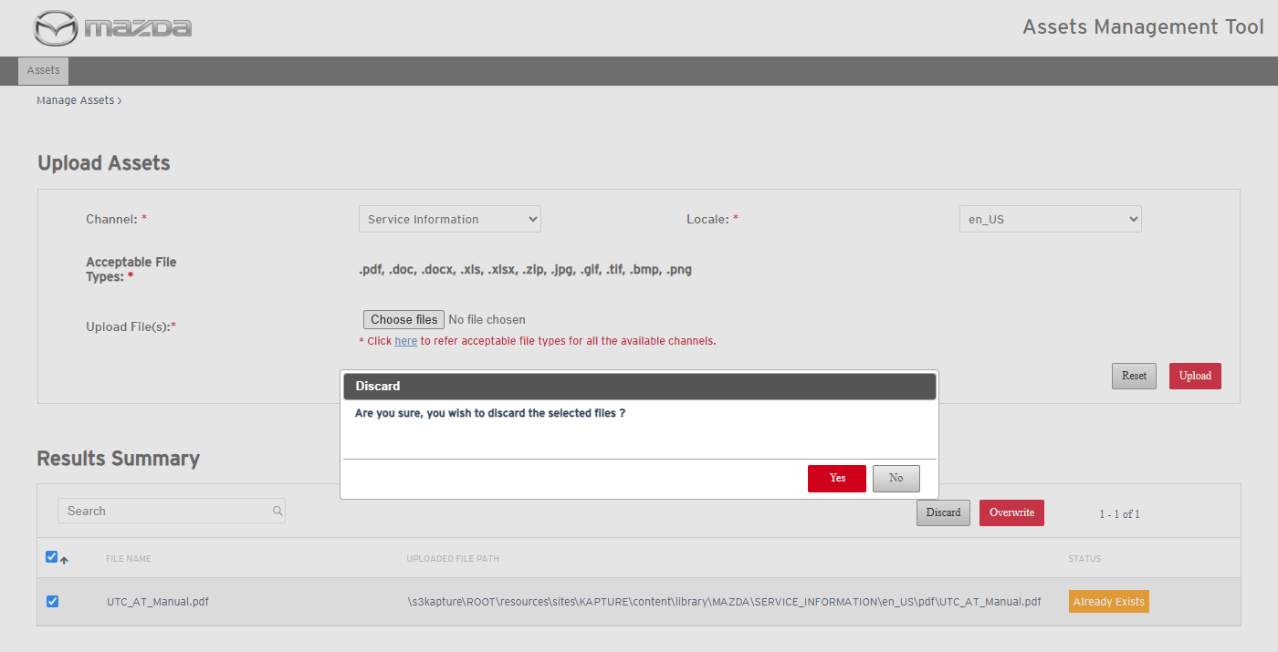
Discard confirmation
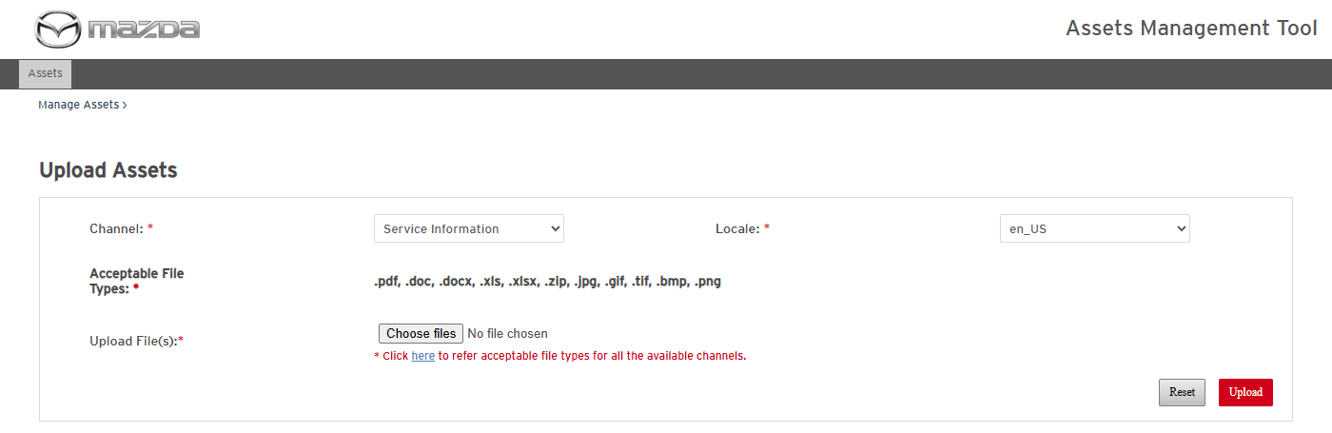
After discard
Status: Pass
Remarks:

Reset
- User should be able to reset the complete form.
Steps:
1. Select a channel / locale and choose a file.
2. Click Reset and confirm with Reset.
Expected Result: "Are you sure, you wish to reset the complete form ?" is asked; channel, locale, file and results are cleared.
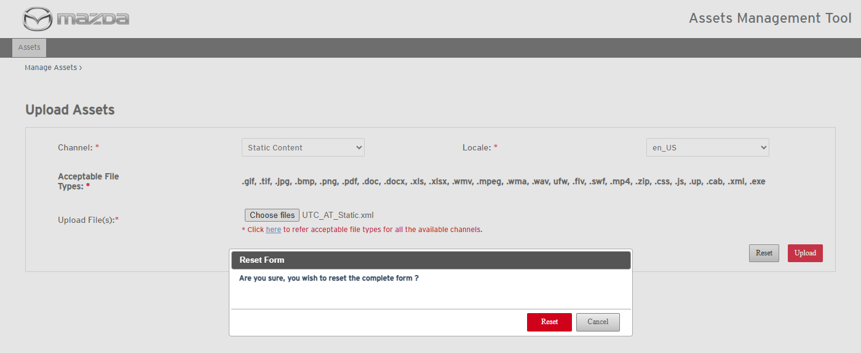
Reset confirmation
Form after reset
Status: Pass
Remarks:

